ISO 9001 Registered


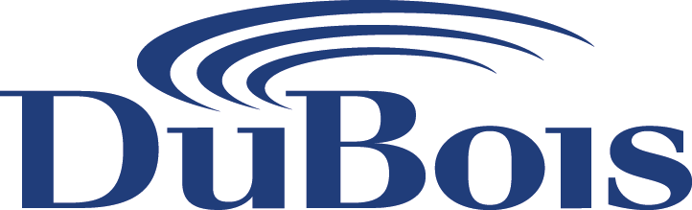

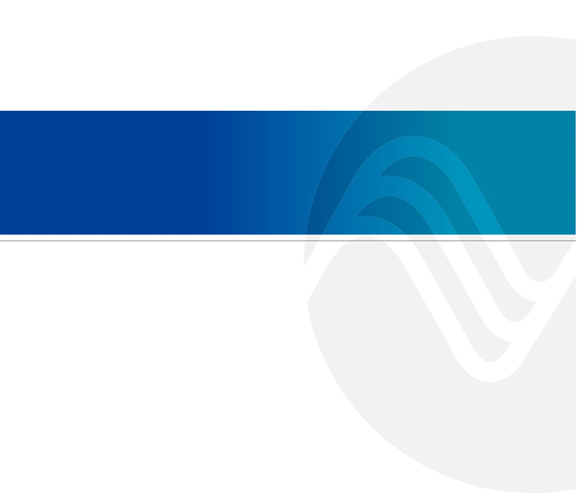

Ya YA Foods Corp., Ogden, Utah
Water Treatment Proposal October 7, 2025
Maurizo Lato, P. Eng., CEM
Business Director – Projects & Construction

Jeremy Hsieh B.A.Sc.
Technical Representative – Projects & Construction

Claire Matsumura
Sales Representative

Shawn Presher
Regional Service Manager

1-888-712-4000 • www.duboischemicals.com

Table of Contents

Introduction 3
Quality Control Program……………………………………………………………………………………………………………………… 7
Process Control Monitoring & Alarm 9
Service Reports 12
Routine Services 18
Continuous Improvement 19
Training 20
Startup Plan to DuBois Program 21
DuBois Treatment Solutions – Cooling Tower and Cleaning 22
Appendices 24
Appendix A - System Information and Target Parameters 24
Appendix B – Cooling Tower Passivation Program Pricing 26
Appendix C – Cleaning and Initial Closed Loop Filling Pricing 28
Appendix D – Pricing Summary by Program 32
Appendix E – Product Technical Data Sheets………………………………………………………………………………………… 33

- Introduction
DuBois – Where Chemistry & Process Knowledge Meet.
DuBois is a leading single source specialty chemical supplier. With over 75 years of water treatment expertise and a strong commitment to continuous innovation, DuBois can provide comprehensive lines of chemical treatment and equipment solutions for your cooling, heating, closed loop and wastewater challenges. We are currently servicing thousands of customer sites throughout Canada, the United States and Mexico.
DuBois offers Water Treatment, Heat Transfer Fluids, Cleaning & Sanitation Products & Lubricants across North America and is therefore positioned to bring exceptional value to Ya YA Foods.
DuBois has recently made acquisitions of companies that bring dedicated Canadian manufacturing and supply chain to serve our customers. These acquisitions have significantly improved our cost position and our ability to pass on these cost savings to our customers. Dubois has manufacturing facilities across Canada and the U.S. to support all our North American customers.
Unlike most water treatment providers, DuBois owns its formulations and manufactures 99%+ of its water treatment products within North America, supporting jobs and industry in both the U.S. and Canada.
DuBois has significant resources to support all our customers with 500+ field support staff, 12 technical centres, 19 manufacturing plants and over 30 warehousing facilities in North America. We are focused on supporting and growing our entire business.
Effective water treatment programs hinge on three critical elements: onsite service performance, reliability, cost and performance. While the direct cost of water treatment is typically a small fraction of overall operational expenses, inadequate service jeopardizes optimal performance and cost-effectiveness. Poor product performance can lead to significant equipment failures and downtime, which far outweigh any program cost savings.
Ultimately, the success of a water treatment program is driven by the local representative's expertise in establishing robust chemistry and predictive monitoring. Their ability to collaborate with onsite personnel and leverage laboratory and research resources is paramount.
Companies like DuBois Chemicals emphasize a service-oriented approach, focusing on data-driven processes to achieve the lowest life-cycle costs. Their representatives, often possessing strong technical backgrounds, act as proactive consultants dedicated to improving customer operations and protecting equipment. This hands-on approach, coupled with extensive experience and ongoing training, positions their personnel as trusted advisors within the industry.

A Global company with a North American Focus
Our Facilities Span Across the Globe. The DuBois corporate office is in Sharonville, Ohio with our brand operations, including technical centers, manufacturing facilities and warehouses spanning across North America and the world.
North American Footprint
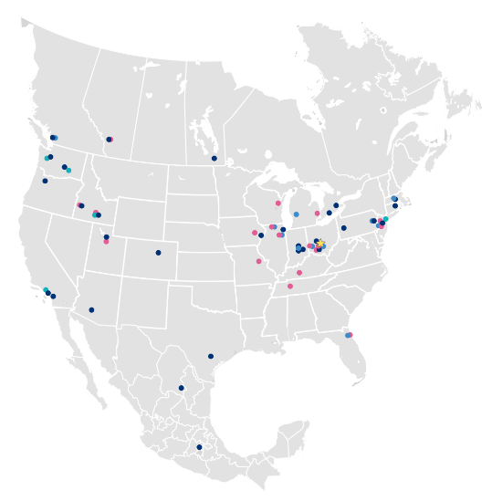

Local Support – Utah Region Field Presence and Emergency Response
DuBois maintains a strong and growing presence in the Utah region, with a significant customer base. Our representatives are trained to respond quickly to urgent inquiries and are fully equipped to service and troubleshoot all supplied equipment and water treatment programs. They are backed by DuBois’ extensive internal resources, including laboratory analytical services, cloud-based reporting platforms, technical specialists, a comprehensive chemical and parts inventory, and fast delivery capabilities.
DuBois also maintains a strong local team, enabling us to offer reliable and responsive emergency services. We aim to respond to emergency calls by phone immediately and can typically be on-site shortly thereafter. If a situation cannot be resolved remotely, a technician is dispatched without delay to provide on-site support.

Innovation & Environmental Impacts
DuBois developed the philosophy that a successful water management program encompasses, mechanical conditioning, chemical conditioning, automated controls and effective data management. We believe in achieving the correct conditions in the systems through our expertise, experience, highly qualified people and practical implementation. Due to this “Water-In-to-Water-Out” philosophy, DuBois has earned a reputation as an expert in water chemistry as well as a market leader in results-oriented water management programs.
Innovation plays a critical role in reducing operating costs, lowering consumption of natural resources and eliminating waste that must be disposed or further treated. DuBois takes pride in delivering cutting edge technologies that reduce your chemical, water, labor and energy costs.
DuBois leverages over 200 Chemists and Engineers across twelve Technical Centers of Excellence to address your specialty chemical needs.
DuBois Chemicals adheres to EcoVadis standards, demonstrating our commitment to sustainable and ethical business practices. By aligning with these globally recognized benchmarks, our customers can trust that we prioritize environmental, social, and governance (ESG) principles.
This dedication includes reducing environmental impact, upholding fair labor practices, and maintaining high ethical standards; helping our customers advance their own sustainability goals through responsible partnership.
Sustainability Initiatives: DuBois Chemicals has a commitment to sustainability and has targets and performance measurements related to their operations, products, and suppliers.
Environmental, Health, Safety & Sustainability (EHS&S) Programs: We maintain strong ESG programs within our operations, with monthly reviews by a dedicated committee and quarterly reviews by the Board of Directors.
Product Stewardship: DuBois emphasizes responsible practices throughout the lifecycle of their chemicals, aiming to minimize adverse effects on human health and the environment. ¹ This includes proper handling, use, and disposal.

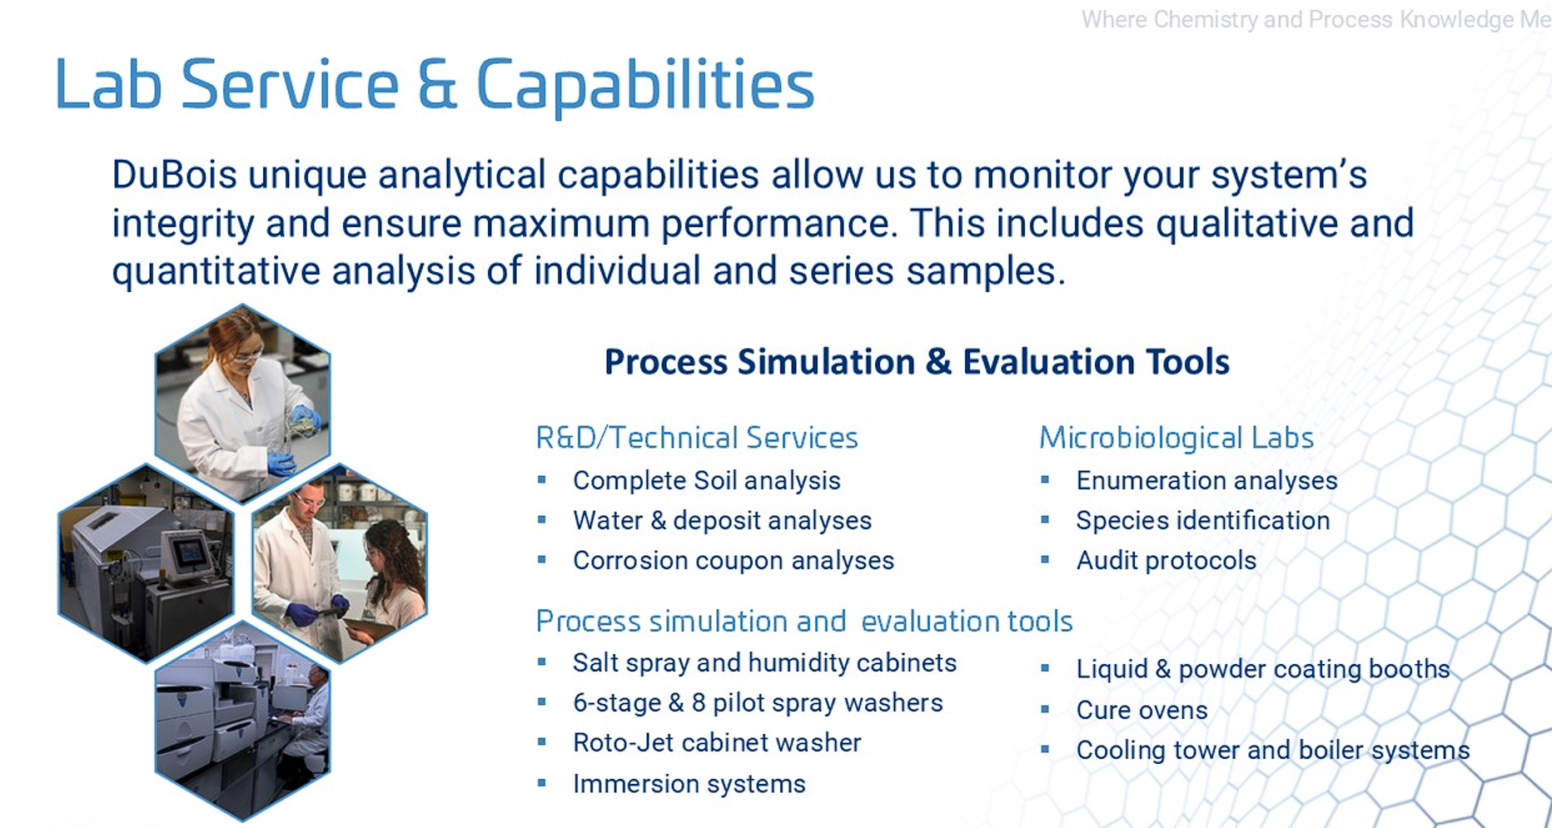

Accreditation
DuBois sites are certified by ISO 9001: 2015 Quality Management System and its laboratories are ISO 17025 accredited. DuBois implements a Target Zero Safety Program with its employees, suppliers and customers.

R&D Capabilities
One of DuBois’ R&D specific capabilities includes the ability to formulate and produce as required customer-specific products based on application-focused analysis and troubleshooting using high-end methods and processes.

- Quality Control Program
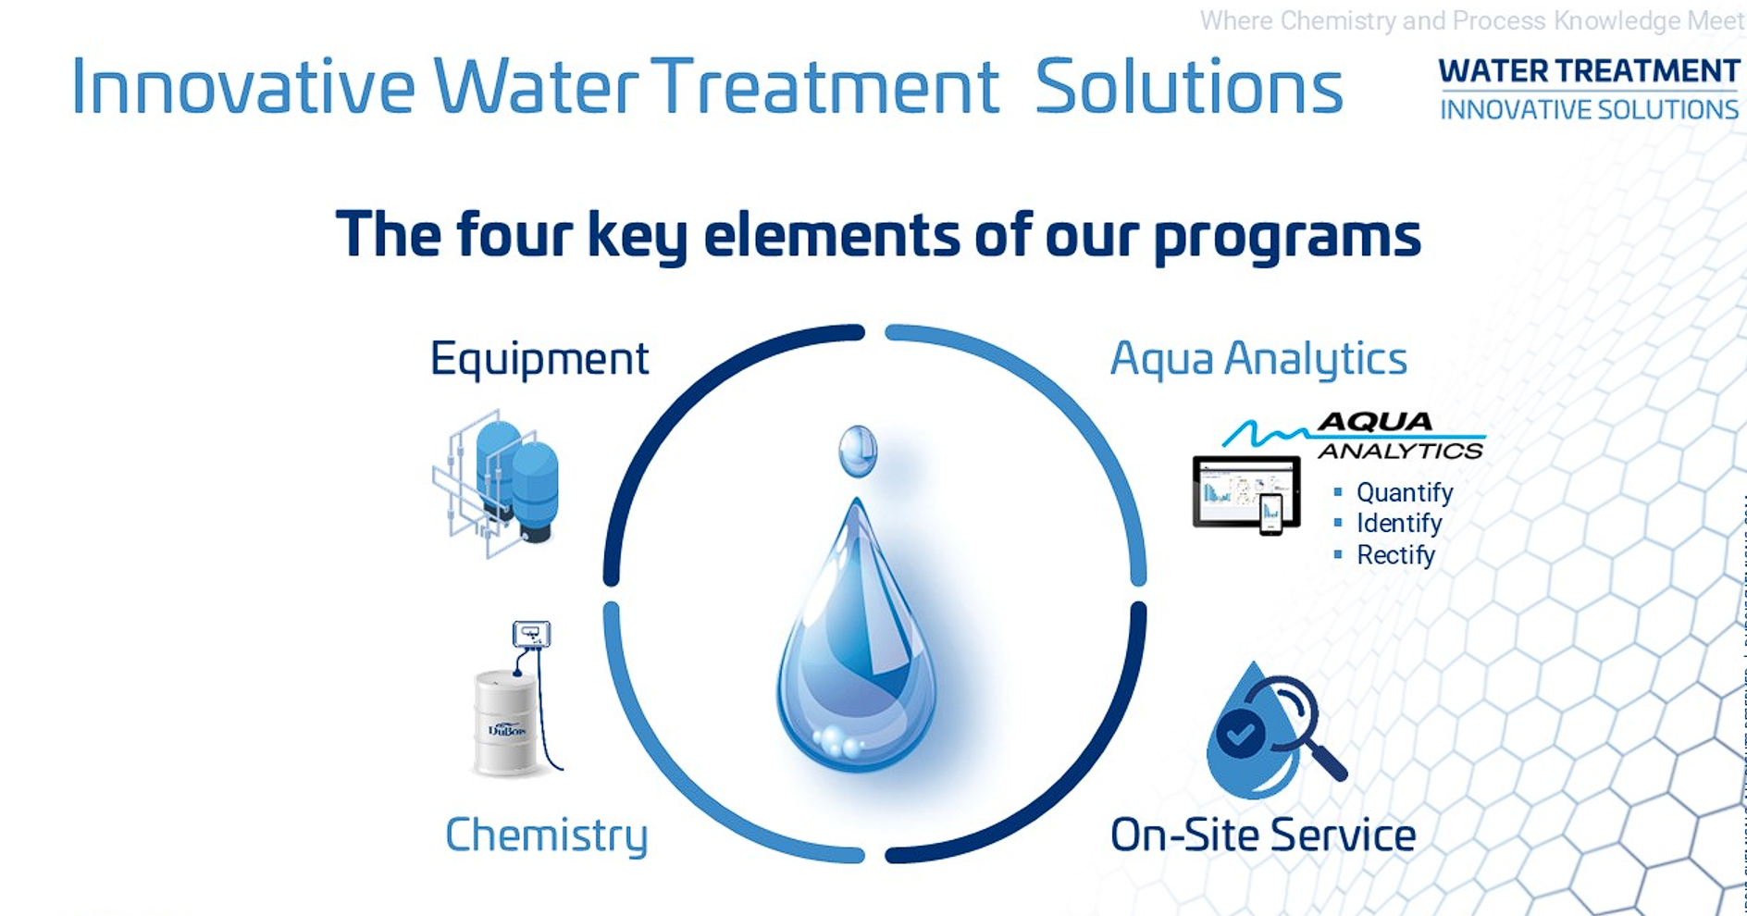

The AquaAnalytics Water Management Program
We are an ISO certified company, which means we have quality standards, KPI and performance metrics for everything we produce & in how we operate. We believe that our water treatment programs at our customer locations are our products. Our service program is a Quality Management System (QMS) that helps in maintenance and performance of the program. Our AquaAnalytic Water Management Program helps us to take corrective actions before there can be a results issue.

The success of our water management programs is based on strict attention to five main areas responsible for its success.
- Pre-Treatment Equipment
- Water Treatment Products
- Chemical Feed Equipment and Controls
- On-site Technical Service and audits
- Cost Optimization via Cost Avoidance

Your DuBois Representative(s)
Your DuBois service representative is the glue that binds these components, so they work together. A program that operates consistently with minimal deviation with a process to track and adjust exceptions will lead to overall reduced operating costs.
Your treatment program is custom tailored to the specific needs of your applications by your technical representative and set up in our AquaAnalytics software. Our AquaAnalytics program is designed to keep the treatment program within the prescribed limits and escalates any deviations.
Keeping results within the set parameters allows for the optimization of operating costs and the extension of equipment life spans by driving corrective action. AquaAnalytics also tracks water usage, controller data, inventory and equipment status.
Consideration is given to the treatment method, target treatment concentrations, results range, optimal cycles of concentration based on TDS and incoming water. On the mechanical side, control equipment is evaluated as well as the pre-treatment requirements.

Our Water Management Programs focus on:
- Preventing scale and minimizing corrosion in boilers, cooling towers and closed process loops.
- A Legionella risk management program for the towers.
- Equipment improvement consultation for all chemical feed and control systems as well as any pre-treatment equipment.
- Maintaining or improving system efficiencies.
- Generating program savings by minimizing energy, water and/or chemical consumption.

- Process Control Monitoring & Alarming
DuBois’s web‐based communication platform, AquaAnalyticsTM, provides logging, trending, and 24/7/365 notification of all critical water treatment parameters. This software consolidates data from service reports, operator logbooks, and inline monitors and sensors. Color‐coded displays allow easy interpretation, and our sophisticated built‐in logic provides predictive analysis.
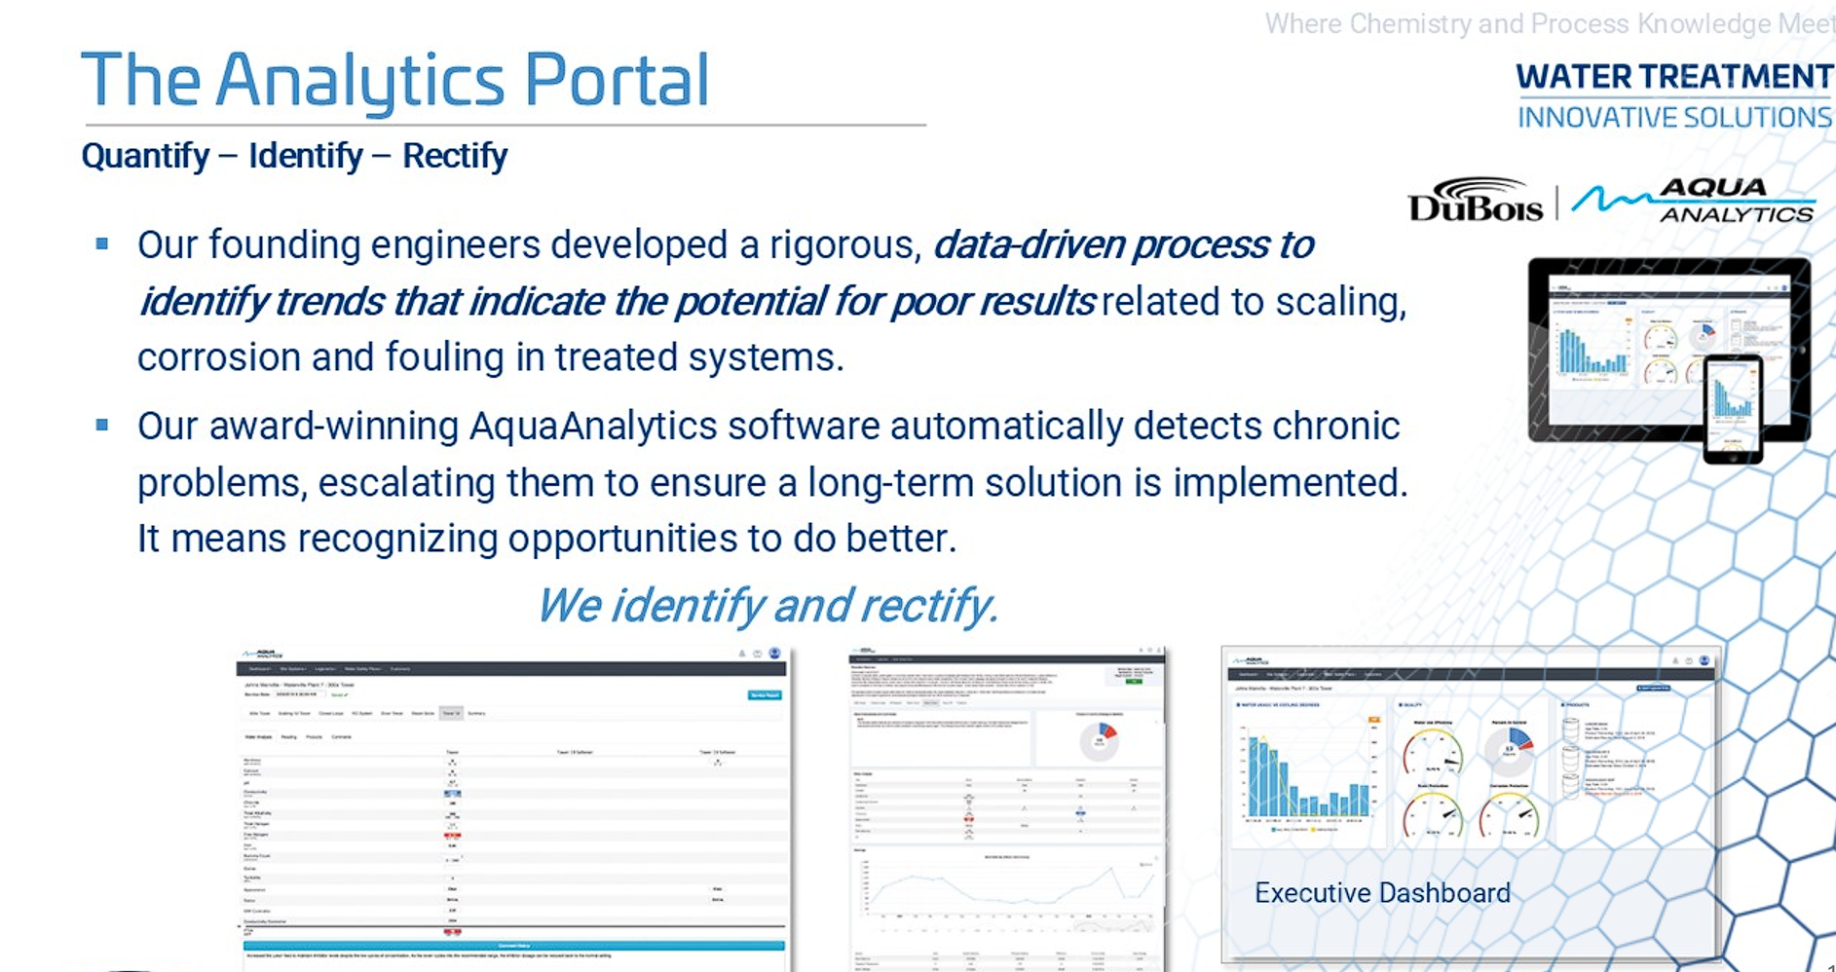

Our award-winning AquaAnalytics software automatically detects chronic problems, escalating them to ensure a long-term solution is implemented. It means recognizing opportunities to do better. We identify it, quantify it and rectify it.
DuBois firmly believes in implementing long term solutions to optimize system efficiencies by further analyzing metadata and the resulting trends. Our service representatives collect and report over 20,000 data points into our AquaAnalytics software each month. On average, 5% of the data points are out-of-range, initiating immediate corrective action during the service visit.
Our AquaAnalytics software uses IF/THEN algorithms to identify and flag reoccurring results deviations based on historical data, which we call "Exceptions". Each month, 2% of the 20,000 data points create Exceptions, which in turn initiates revisits for further corrective action.
Unresolved Exceptions become "Escalations" - approximately 0.1% of our monthly data points. At this point, upper management is notified, and action plans are developed to rectify the problem(s) and Continuous Improvement opportunities with ROI are presented to you for review and decision.

Other sources of data include web-based controller reports & alerts, online logbook alerts through operator testing. Your DuBois Representative uses the data collected through the various water meters, monitoring probes, level sensors, temperature and pressure sensors, etc., to react quickly to non-conformances and present continuous improvement opportunities in pursuit of the least-cost operating scenario for your facilities. Implementation of effective real time monitoring, datalogging, immediate alarming and daily status reports has generated savings for our customers in excess of their entire water management bill.

Online Logbook

Our cloud based AquaAnalyticsTM logbook, puts all the computing power of our service reporting software in the hands of the operator. This online logbook eliminates piles of ineffective paper logs and allows facility managers to effectively track system performance. Test results outside the recommended ranges are highlighted blue or red for easy identification and automatic alerts of any non‐conformances are also sent to your DuBois service team to facilitate strong communication regarding your water management program.
Your DuBois Representative uses the data collected through the various water meters, monitoring probes, level sensors, temperature and pressure sensors, etc., to react quickly to non‐conformances and present continuous improvement opportunities in pursuit of the least‐cost operating scenario for your facility. Implementation of effective real time monitoring, datalogging, immediate alarming and daily status reports have generated savings for our customers more than their entire water management bill.

Legionella Portal

DuBois cloud-based Legionella portal is used to manage the testing and reporting of Legionella for cooling water systems as required in Quebec and other jurisdictions across North America.

Technical Reporting (Monthly or As Required)
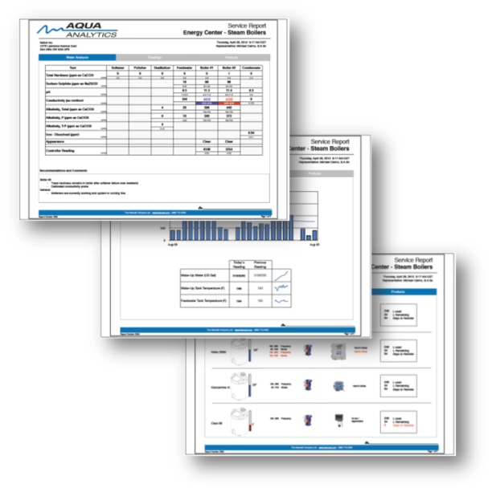
The AquaAnalytics Report is generated on site and reviewed with facilities staff at the end of every service visit.
All reports are archived in our AquaAnalytics database and can be accessed at any time. Our proprietary cloud based AquaAnalytics service reporting software automatically trends all historical service data to identify trends in data that signify potential for poor results related to scaling, corrosion, or fouling in treated systems. This sophisticated logic allows us to predict results that would only otherwise be observed during the annual equipment inspection. Any exceptions generated from non-conformances in the program are reviewed by upper management and action plans are developed and implemented.
We believe that constantly monitoring results and swift reaction to non-conformances are the best ways to optimize the life of capital assets while minimizing water, energy, and chemical expense. Therefore, we promote the use of reliable automation to keep the program on track in between service visits.

Quarterly Program Reviews of KPIs
A business in-person review is performed with the stakeholder to discuss the results of the water management program, true cost, and future objectives. In addition, all items listed under the Continuous Improvement section are addressed during this Business Review meeting. A summarized report and meeting minutes are sent to key contacts following the meeting.

- Service Reports

Our clients receive the access to the leading reporting platform in the industry: AquaAnalytics. At a glance, they provide a snapshot view of the current water treatment control. These service reports are emailed to the client, from the site, as we perform the service visit. The reports have always contained a summary: “Here is what I’ve found, here is what it means for your system, here’s what I did to fix it.”

Improvement is Not an Event; it’s a Continuous Process!

Our belief is that improvement is not an event, it’s a continuous process. That is why we have launched two major AquaAnalytics innovations, that our team has been diligently working on behind the scenes, that will further improve the way we communicate important information regarding your water management program with you.

Dashboard View
The dashboard view is intended to present what matters most to you – through comprehensive yet simple to understand KPIs. These KPIs are based on algorithms developed through our two decades of electronic data gathering expertise, identifying trends before they become problems:
- What is your Water Consumption Trend?
- Your Percent In Control (PIC) Rating.
- Your Water Use Efficiency Score.
- Your Scale Protection Score.
- Your Corrosion Protection Score.
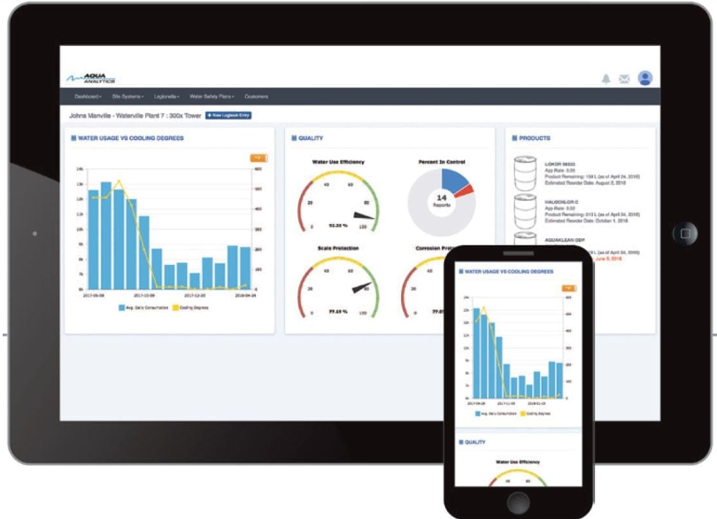

KPI Based Dashboard
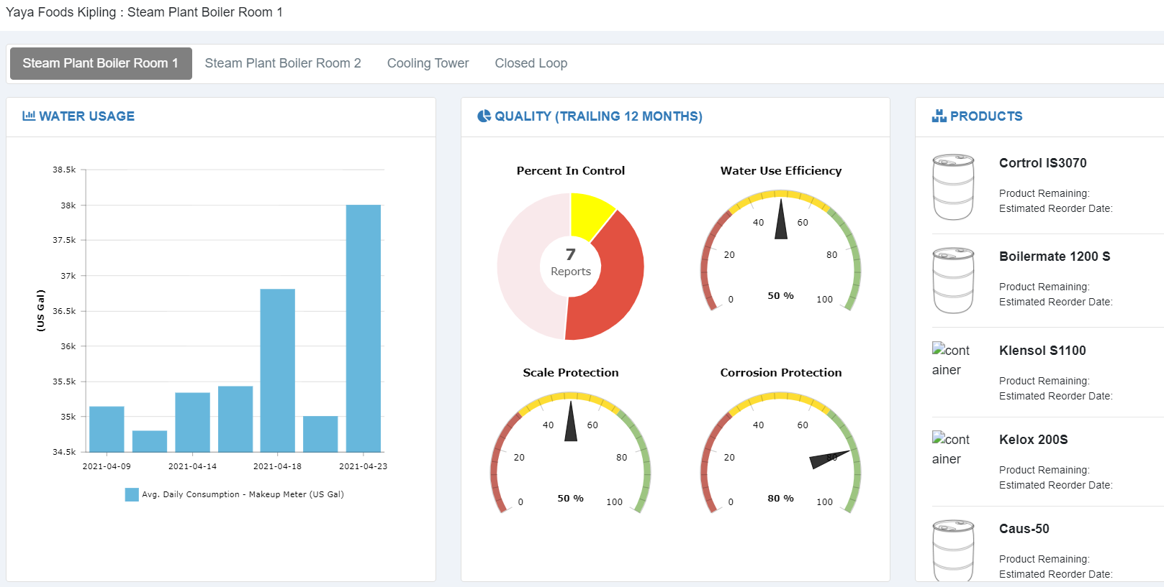

Live Readings and Alarms from Web Based Controllers (Example)

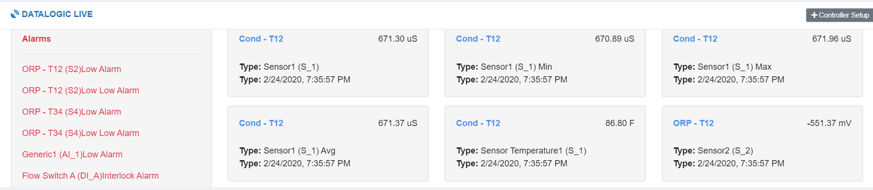

Interactive Service Report (Unique in the Industry)
Your plant is not static in time… why should your service report be? The re-invented AquaAnalytics service report is polling data from the portal to be fully interactive. We all know “You can’t manage what you don’t measure”, but in this information overload world, ease of access to the right information is more important than knowing the information exists. From graphing to historical trending, the information in the AquaAnalytics report is a click away.

Steam System

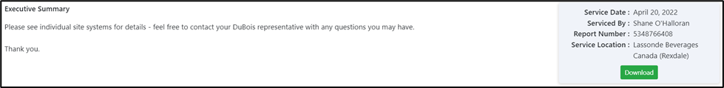

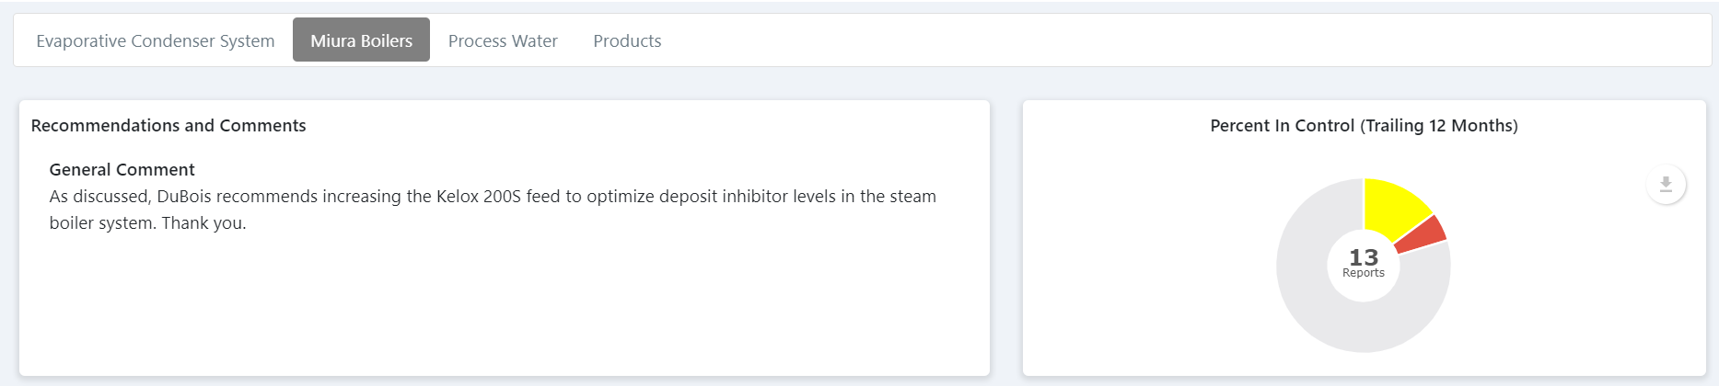

Water Analysis Data for Pre-treatment, Feed water, Boiler Water and Condensate
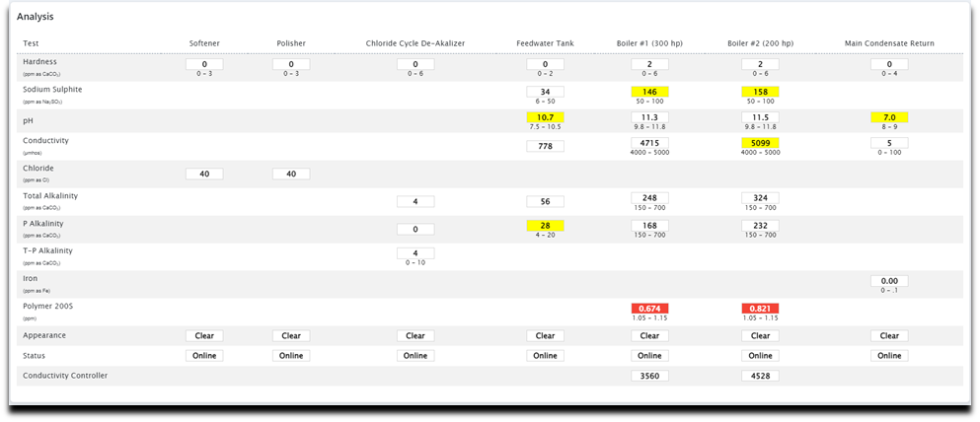

Water Usage Trend & Feedwater Performance
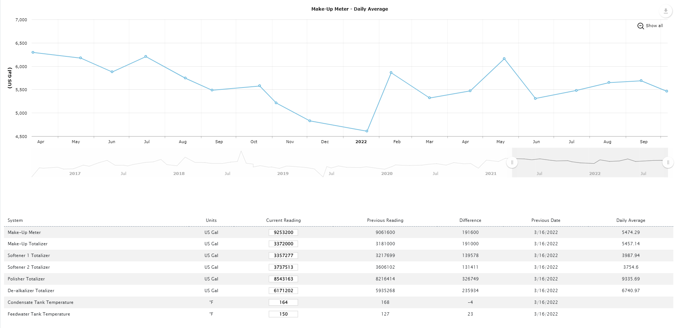
Cooling Tower Recommendations and Comments with Percent in Control
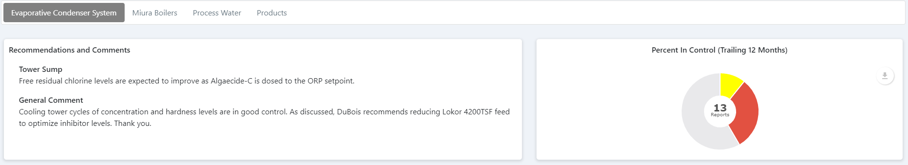
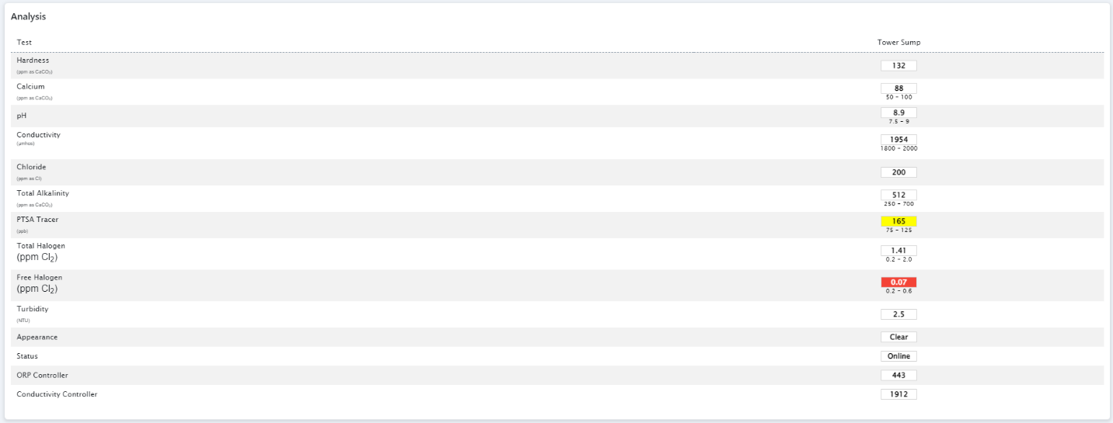
Analytical Data

Cooling Degree Days V/S Water Usage Trend (Example)
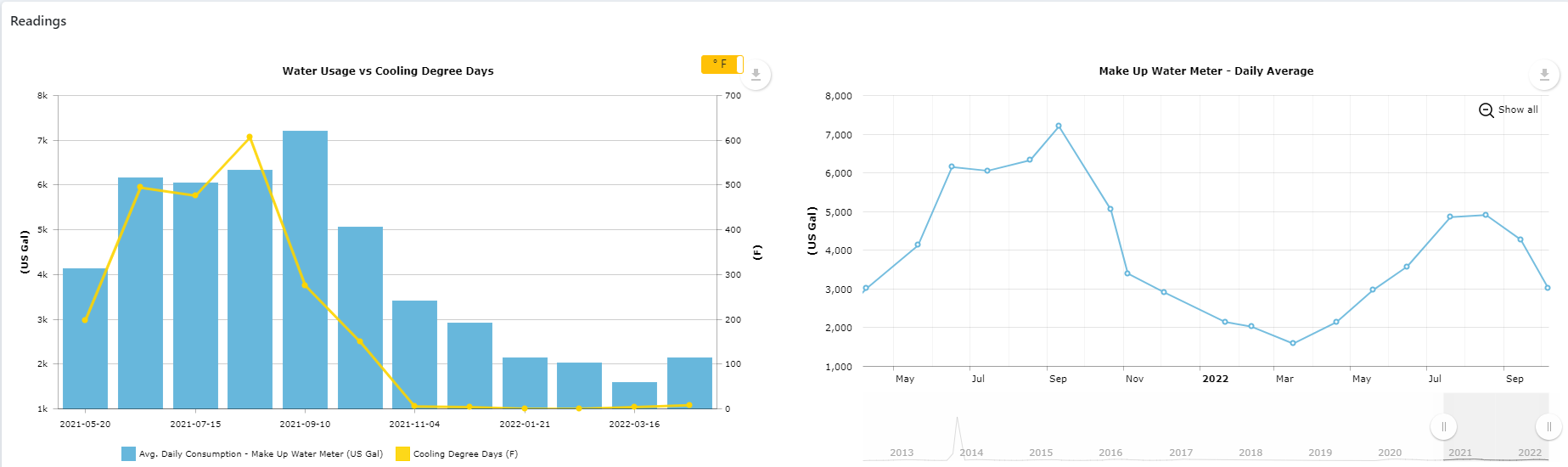
Cooling Tower Data – Water Usage, Bleed Rate, Condenser & Evaporator Approach Temperatures (Example)
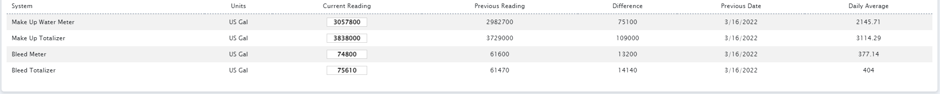

Closed Loop System Recommendations and Comments with Percent in Control

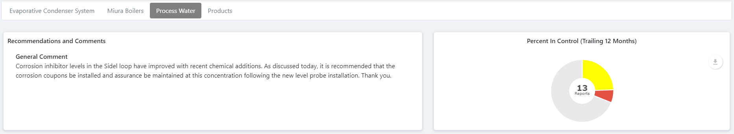
Analytical Data
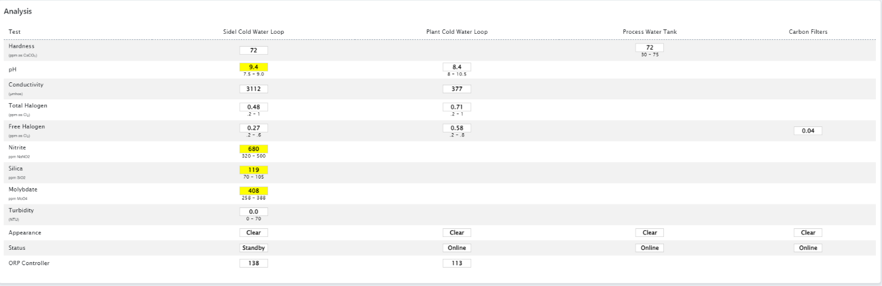

Closed Loop Data
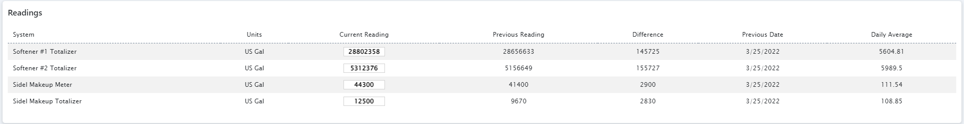

Inventory details, Feed Adjustment, Re-order information (Example)
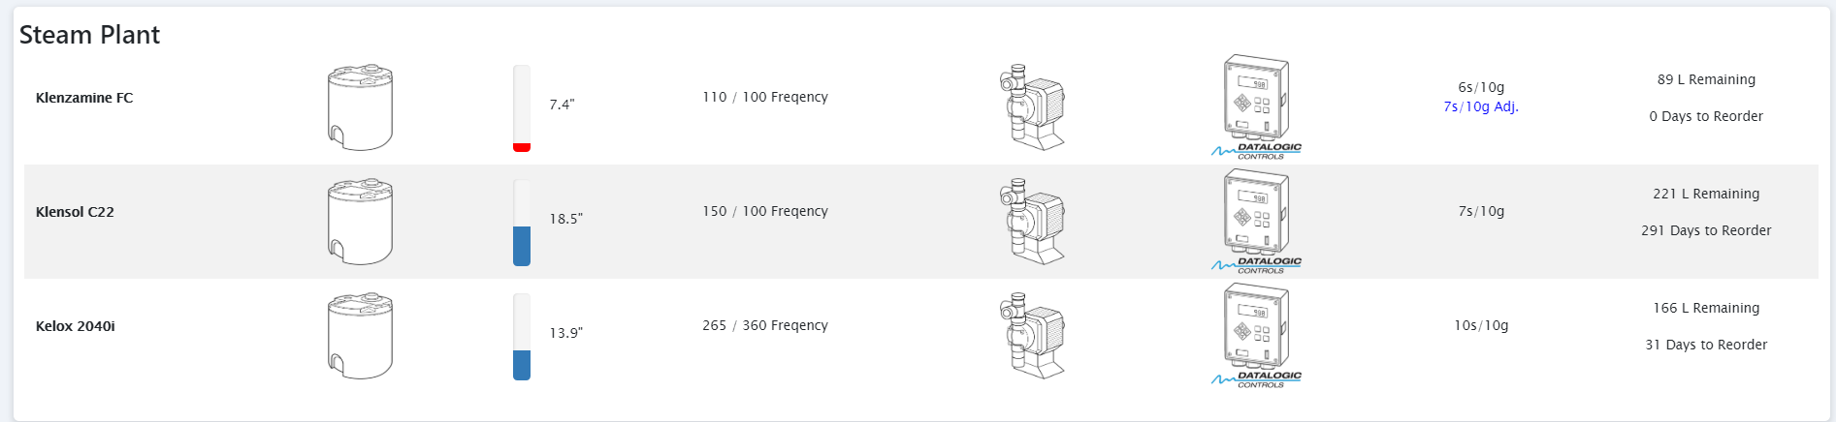
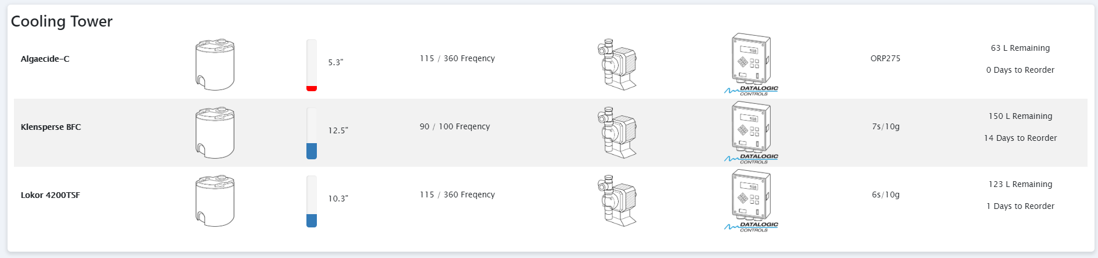
Copper Silver Ionizer Data

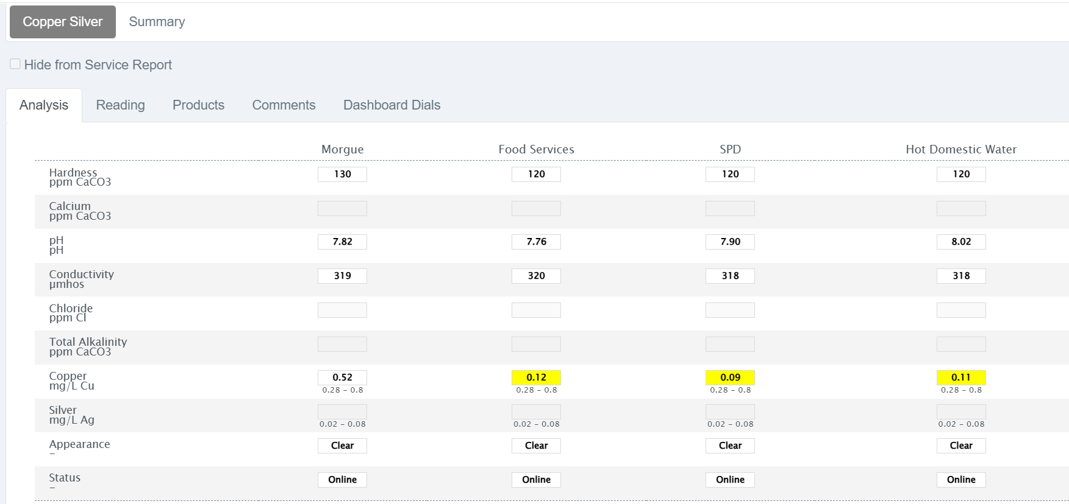

DuBois Routine Services
Below is a list of Routine Services that we typically draw from when managing workflow.
1. Laboratory analysis to monitor mass balance of hardness and heavy metals throughout the systems.
2. Oxygen studies on deaerator, feedwater and condensate.
3. Condensate corrosion studies.
4. Cooling and closed system corrosion studies.
5. Microbiological control studies on cooling water.
6. Training for new operators and regular operator refresher courses, including altered programs or procedures and safety issues, such as WHMIS.
7. Tracer studies to monitor retention time in cooling systems.
8. Review and update computer programs, operating manuals, control charts, test procedures, and equipment.
9. ATP monitoring.
10. Microbiological culture analysis.
11. Verify calibration of on-site test equipment and testing accuracy by plant operators.
12. ASTM steam purity testing on the boilers.
13. Preparation of standard specification for new construction equipment.
14. Prepare standard specification for new construction piping clean, flush charge operation.
15. Management of new construction water treatment equipment installation.
16. Management of pre-operational cleaning of new systems.
17. Professional engineering stamp approval for rebate applications.
18. Review of operations with operators.
19. Review operator records.
20. Verbal reporting to management.
21. Service summary report.
22. Chemical consumption review.
23. On site water system analysis.
24. Chemical inhibitor and reagent inventory audit.
25. Operator test equipment calibration.
26. Equipment inspections and reports.

- Continuous Improvement
At DuBois, one of the highest priority activities is to help our customers reduce water and energy. All field representatives complete 18 months of technical training to qualify them to effectively identify opportunities. We use the qualitative benchmarking tool to assess the existing water management program at each new site:
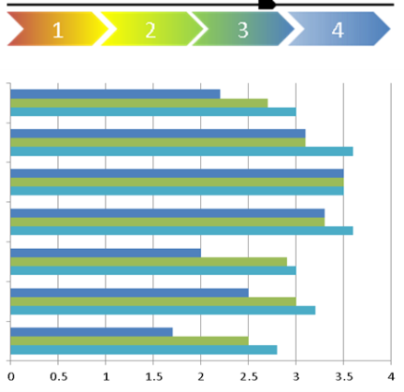
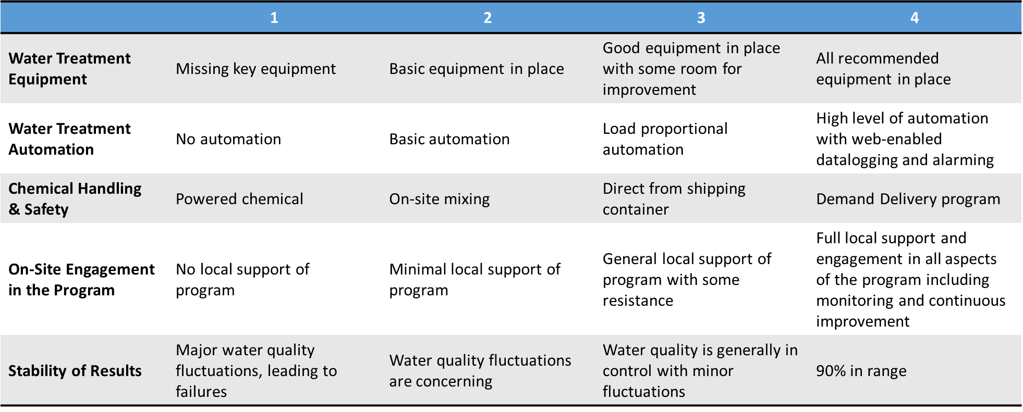
DuBois continues to use this benchmarking tool to track progress of each site to prioritize the allocation of resources during reviews. It has proven to be a great, high-level tool to ensure all systems are showing continuous improvement to ensure we are moving towards our goal of minimizing the overall operating costs.
Continuous improvement recommendations are provided on every service report. Unique return on investment (ROI) opportunities are also presented regularly in pursuit of the least cost operating scenario for our customers. We believe in taking a “big picture economic approach” and we promote the use of products and upgrades regardless of the economic value to DuBois. Many of the continuous improvement projects we recommend that save water and energy, also reduce the use of our own chemistry, and hence lower the chemical cost directly.

- Training
The success of our water management program is dependent on a strong working relationship with our customers. Training sessions are offered to foster continuous development in the following areas:

• Understanding your water management program (system diagrams, purpose of each
chemical, chemical safety, etc.). A program manual is provided.

• How to complete regular checks on the systems (water tests, visual checks, recording in
paper or electronic logbooks, etc.)

• Understanding when to contact your DuBois representative for assistance (control charts
provided with conditional action recommendations)

• Operating the mechanical equipment in accordance with manufacturer and industry best
Practices

DuBois provides a large array of training materials for our customers, from basic water test, Procedures and Control Charts to more detailed Engineering Notes that provide objective education on various topics related to water treatment such as chiller / boiler efficiency, layup procedures, passivation of galvanized surfaces, legionella risk management, etc.

Targeted PowerPoint training sessions are delivered one-on-one, in group settings, or remotely via online seminars. In all cases, the sessions can be recorded to create a web-based archive of slides and audio. DuBois has also published “Boiler Water Treatment Simplified” and “Cooling Water Treatment Simplified” manuals for general water treatment education. DuBois provides training at no additional cost.
Safety | DuBois will perform a site evaluation to determine logistical requirements and to identify and address any safety concerns. Product information will be posted at every chemical treatment station to ensure all operators are comfortable with the transition.
Startup | Our program startup team commissions the system and provide weekly follow-up for an initial period. Our hands-on approach and quality service gets your program on target from day one. We will continue to visit frequently to quickly rectify any outstanding issues.
Technical Service | Our minimum service frequency is monthly. However, DuBois is the only service provider with an ISO approach to repeat visits. This ensures prompt resolution to program deviations as they arise. Our customers frequently receive more than 12 visits per year.
- Startup Plan to DuBois Program

Training | The most effective training occurs on site. DuBois provides a large array of training materials for our customers, from basic Water Test Procedures and Control Charts to more detailed Engineering Notes. Training is customized to the specific needs of your facility.
Online Portal | Each DuBois customer has a dashboard view in their online portal that holds their entire DuBois history at a glance. Customers can access this information anytime, anywhere and easily generate summary reports, enter critical log-book data, obtain SDS, and reach their service representative
Inventory | DuBois will assume responsibility of your inventory management. Your Inventory is recorded on the Aqua Analytics service report. Standard chemicals are available for same day shipping. Our inventory management system ensures 99% compliance to this rule.

- DuBois Treatment Solutions Descriptions

COOLING TOWER TREATMENT PRODUCTS

Monitrol 4120 uses a highly concentrated blend of synergestic inhibitors, innovative polymeric dispersants, and deposit penetrant for recirculating cooling water systems and is halogen stable. This product is traced for application based on PTSA probe.

Trexcide 322 is a halogen-based liquid oxidizing microbiocide which controls growth of algae, bacteria and fungi in recirculation cooling water systems. The product is applied to the system directly from its shipping container to maintain the recommended balance in the cooling water. Algaecide C is registered unter the Pest Control Products Act.

Aquaklean ODP is an effective bio-dispersant designed to remove and disperse organics. Organics and biological growth can cause the formation of deposits and/or tacky films which may act to shield microbes and adversely affect operational performance. This product, in combination with Trexide microbiocide, has been shown to be extremely effective in removing these films and deposits on system surfaces, and in controlling biological activity, algae growth as well as Legionella in the bulk water.

Korpass CT is designed to effectively suppress and control pH levels in open recirculating cooling systems. It is commonly used during the initial White Rust Passivation Program for cooling towers with galvanized surfaces. Additionally, the product supports increased cycles of concentration in cooling tower water, helping to reduce water and chemical usage—an important consideration for cost savings and meeting LEED certification requirements.

- DuBois Treatment Solutions Descriptions

CLOSED LOOP PRODUCTS

Molyklenz is a molybdate-based multicomponent mixture that combines corrosion inhibitors for ferrous and admiralty metals with state-of-the-art polymer technology that stabilizes scale forming minerals in solution. In is generally used in chilled water systems or in loops with mitigated temperatures. Molyklenz can be added manually or with a fully automated chemical addition system. Completely closed systems require the initial filling only since water losses are not expected.

Assurance 6330 is a high-quality heat transfer fluid formulated to be safe for use with all metals, except aluminum. It is a pre-blended propylene glycol solution enhanced with a premium corrosion inhibition package to protect system components. Assurance 6330 uses bio-based propylene glycol, derived from edible vegetable oil sources. This makes it a sustainable and environmentally responsible alternative to traditional fossil-based glycols.

PRE-OPERATIONAL CLEANING PRODUCT

Met-All Terj is an all-in-one liquid solution designed for the efficient cleaning of piping in both open and closed recirculating water systems, whether during pre-operational startup or general maintenance. In addition to its use in commissioning a new system, this product can also be applied to help remove ferrous deposits and accumulated debris in existing piping systems.

Appendix A – System Information & Target Parameters

Cooling Tower System:

System Parameter | Description
Recirculation Rate | 6,803 USGPM, 5-cell
System Volume | 21,000 US Gal (estimated)
Makeup Line Diameter | 3”
Make-up Rate | Up to 170 USGPM  (depending on load)

Water Quality Parameter |  | Makeup | Cooling Tower
 | Total Hardness (as ppm CaCO3) | 120 – 240 | 150 - 500
 | PTSA Tracer (ppb) | 0 | 75 - 125
 | Conductivity (micromhos) | 300 - 600 | 1,000 – 2,500
 | pH | 7.0 – 8.0 | 7.5 – 9.0
 | Alkalinity (as ppm CaCO3) | 90 - 180 | 150 – 500
 | Free Halogen (ppm) | 0.2 – 1.0 | 0.2 - 0.6
 | Cycles of Concentration | 1 | 4 - 8
    - Precise parameter ranges will be determined upon field service visits.

Closed Loop Systems:

System Parameter | Description
Clean Tower Water System Volume | 17,000 US Gal (estimated)
VTIS Chilled Water System Volume | 13,000 US Gal (estimated)
Thermizer Glycol System Volume | 15,000 US Gal (estimated)
Main Plant Glycol System Volume | 8,800 US Gal (estimated)

Water Quality Parameter | Makeup | Chilled Water | Glycol
Conductivity (micromhos) | 120 – 240 | Monitor | Monitor
pH | 7.0 – 8.0 | 8.0-10.5 | 8.0 – 10.5
Molybdate (ppm as MoO4) | 0 | 90 - 120 | N/A
PG Concentration (%) | 0 | N/A | 30

Appendix B – Passivation Program Pricing

Appendix C – Cleaning and Closed Loop Initial Filling Pricing

Appendix D – Pricing Summary per Program

Appendix E – Product TDS

